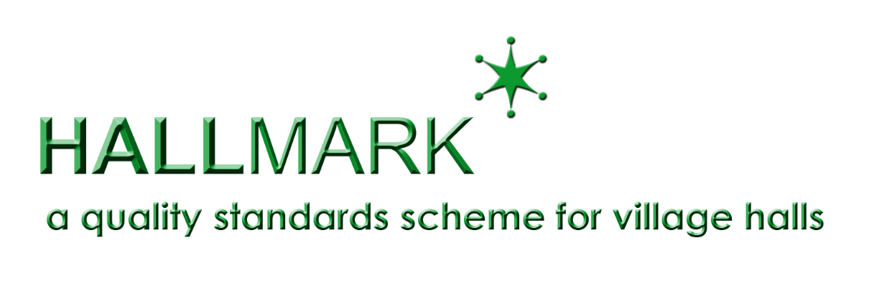 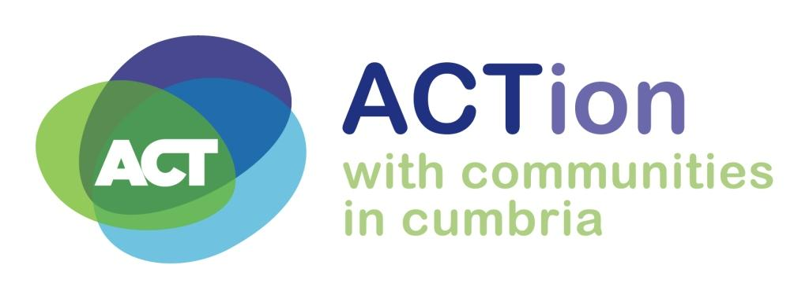

**Hallmark 1: Charity Essentials and Administration**

**Entry Form**

Please read the Hallmark Guidance Notes before completing this form.

|  |  |
| --- | --- |
| Name of Hall: |  |
| Name of main contact: |  |
| Position: |  |
| Contact address: |  |
| Post code: |  |
| Telephone number: |  |
| Mobile number: |  |
| Email address: |  |
| Second Contact - name and telephone number: |  |

Please tick to confirm the following is submitted with your entry form:

* Copy of the hall’s latest accounts
* Copy of the hall’s governing document
* Cheque / BACS for £50 towards the cost of the visit and volunteer travel

|  |  |
| --- | --- |
| Directions to hall from a main road: (please attach map if needed) |  |

|  |  |
| --- | --- |
| Please give an indication of times when a visit might not be convenient e.g. when a playgroup is in operation: |  |

|  |  |
| --- | --- |
| Signed: |  |
| Dated: |  |

|  |  |  |  |
| --- | --- | --- | --- |
| For office use only: | | | |
| Visitor Names: | | | Visit Date: |
| Report received: | Sent to ACRE: | Vol expenses paid: | Certificate awarded: |

ACTion with Communities in Cumbria, Room 11, Redhills House, Redhills Business Park, Penrith CA11 0DT

T: 01768 425666 | www.cumbriaaction.org.uk | info@cumbriaaction.org.uk | Follow us @ACTCumbria

Registered in England as Voluntary Action Cumbria | Charity Registration Number 1080875 | Company Number 3957858